Managing Your Apprentice
2017 Participant Guide

Thank you for attending today’s training! This participant guide will be used throughout the day to work through specific exercises as well as provide a place for you to jot down notes and thoughts as we discuss the unique opportunity to manage apprentices at your organization.
Following today’s session, the slides will be mailed out for your reference. Let’s get started!

On being a supervisor

Starting off Strong:

My “hot Buttons:

Some groundrules:

Need to know:

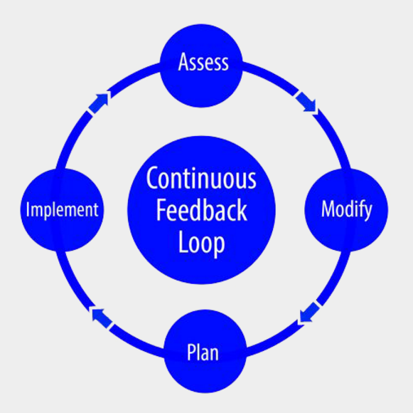
Treat me like I’m an adult (and remember I’m not)

Hannah has picked up quickly on the Accounts Receivable software, moves through her tasks ahead of schedule, and has a great attitude. This week, you have found 2 errors in her work.

What specific questions will you ask?

ASSESS: What is the root cause?

MODIFY: How will you help her adjust?

PLAN: Specific plans for improvement

IMPLEMENT: Do it (and check in)

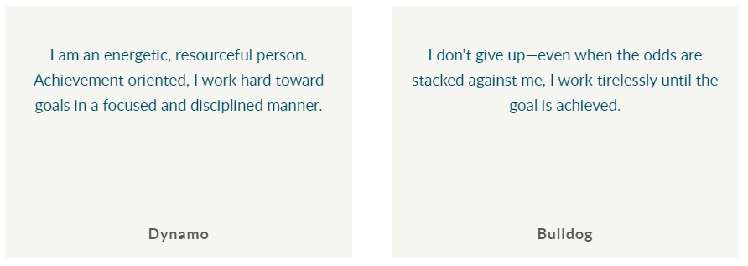
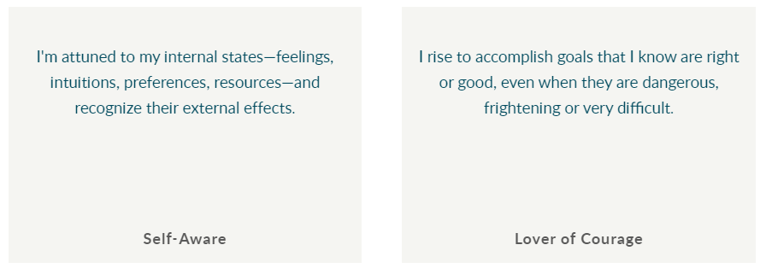

How different is the screen profile from this student? Where will they connect? Where might they conflict?

Solving Problems Together
A supervisor describes how she helped her summer intern take responsibility for planning the clinic’s part in a health fair for children.
1 “As an project coordinator apprentice in our pediatric dental clinic, Sarah planned a dental health station at a Head Start health fair. Ours was one of about nine different stations at the fair, which lasted three days. One station was vision, another hearing. I was asked to plan the dental aspect of it. I turned the planning over to her.”
2 “She was also responsible for making arrangements. It was a big thing for her because she had to put together all of the components. She had to call up the health coordinator at Head Start and introduce herself to this woman. The woman is very busy, so she had to catch up with her first of all. Then she had to tell her that she had been assigned the dental part.”
3 “I explained how I had done it to her because I had done it the year before. I told her to talk to the woman to find out what the woman wanted. So she used me as a resource. I didn’t dictate to her. She planned it, and she gave me a role. She had to find out from the woman in charge where our station for the mobile van was going to be. She had to make a sign. She had to call up the doctors. She had to get the volunteers. She had to make cold calls.”
4 “It would be unpredictable how many people would be in line, so she had to figure out what to do with the people who are waiting. She figured out that this would be a good time to provide some dental health education to them. She also needed to fill out the consent forms. And she needed to record who came.”
5 “She figured out she couldn’t do everything, so my dental assistant needed to help out. I needed to help out. There were a few days when I couldn’t do it, so she knew she needed to find somebody else. She needed to plan for the worst scenario, which is that conceivably all 800 children could show up on the first day. So she had two dentists for each day. And we had toothbrushes and toothpaste.”

What specific foundational competencies will the apprentice develop from this project?

What did the mentor do to try to guarantee the intern’s success?

Brainstorm Projects
What kinds of projects could youth do in your workplace?

Choose a project from the brainstorm list that you would like to develop further with a group.

Design a Project ( 20 minutes to prepare.)
Discuss the following dimensions of the project:
Product What will you have when the project is finished?

Steps What must be done? In what order? By what time?

Criteria What makes a good product?

Learning objectives What will the apprentice get out of it?

Resources What human and other resources are available?

What essential information and advice would you give?

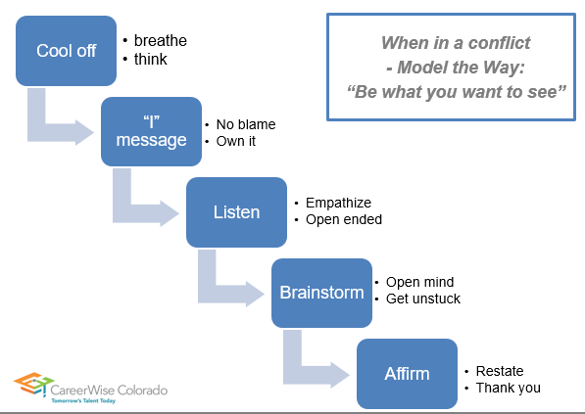

Think about the last difficult conversation you had, or a conversation you need to have… work through each step to practice.
COOL OFF (How will you do it?)

“I” MESSAGE (I’m feeling because…)

LISTEN (list open ended question you might ask)

BRAINSTORM ideas (think big, think different)

AFFIRM

